Assignment 4 ROS

Rafal Grasman

Menno Broeders

**Running our code**

**This document assumes that ~/ros_workspace/ is in your ROS_PATH variable!**

**Contents of zip should be:**

**[folder] assignment4**

**+ .. <other files>**

Extract the zip into ~/ros_workspace/

*Detect the package:*

rosdep update

(if needed, run rosdep init beforehand)

*Build the binary:*

cd ~/ros_workspace/assignment3

rosmake

*Then launch the package: (terminal1)*

roslaunch assignment4 assignment4.launch

Screen after running roslaunch command:

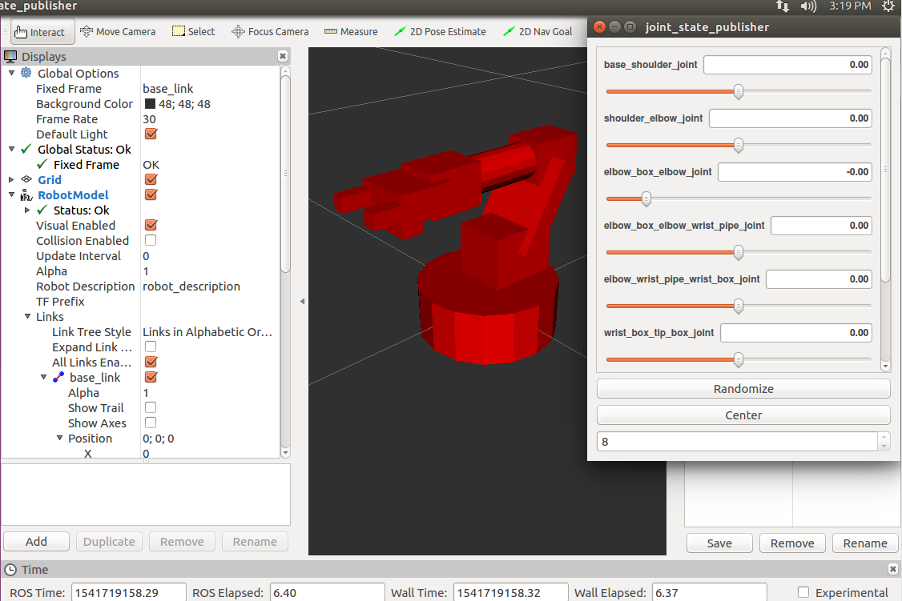

**Joints**

Joints can be manipulated so the robot arm can move, for example (centered and moved):

